TEST CASES: Calculating Highest Common Factor

Test Case | First | Second | Expected Result | Screen shot
#1 | 12 | 18 | 6 | 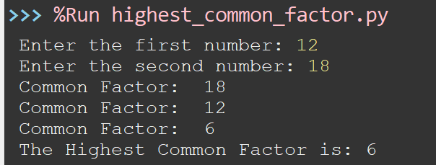
#2 | 7 | 13 | 1 | 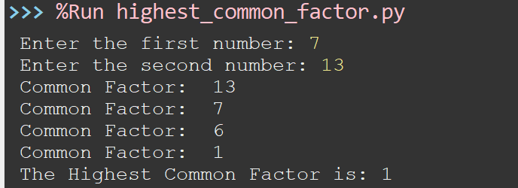
#3 | 10 | 10 | 10 | 